Tutorial 13

Module Name: Python - Selenium Environment Configuration
Test Case ID: TC13
Tester Name: Vora Riya

Scenarios:
- Scenario ID: SET01
Scenario
Verify Python installation
Test Steps
1. Open the terminal.
2. Run the Python version command.
3. Observe the output.
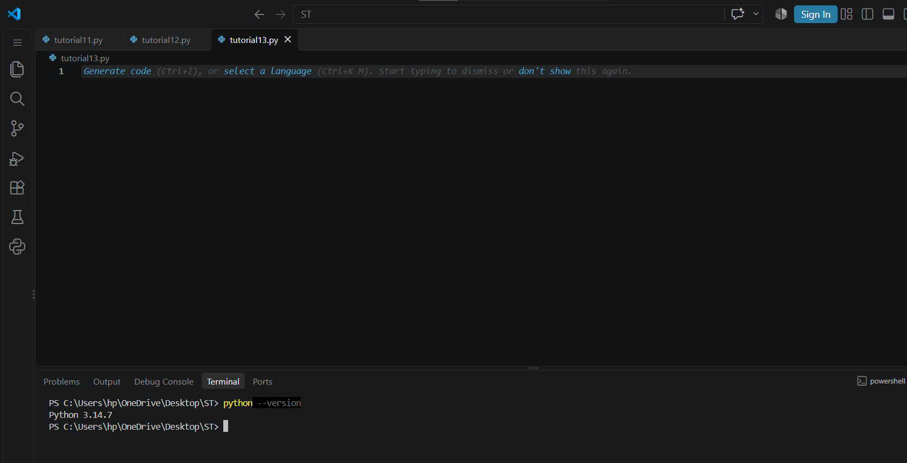

- Scenario ID: SET02
Scenario
Selenium installation
Test Steps
1. Open the terminal in the correct Python environment.
2. Install Selenium package.
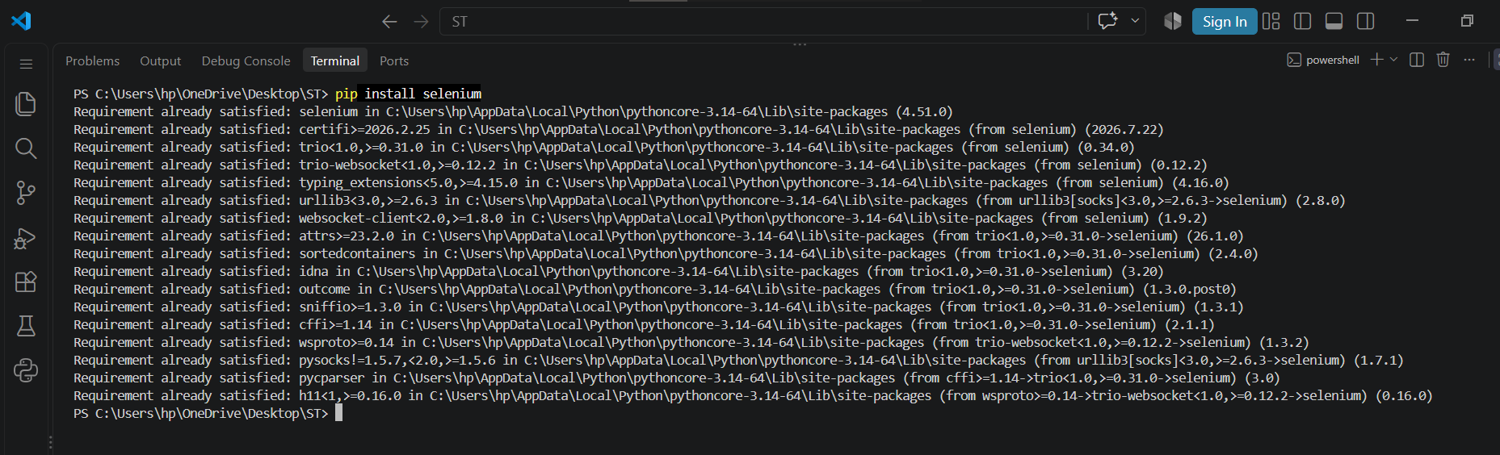

- Scenario ID: SET03
Scenario
Verify Selenium installation
Test Steps
1. Open the terminal in the correct Python environment.
2. Check the installed Selenium package.
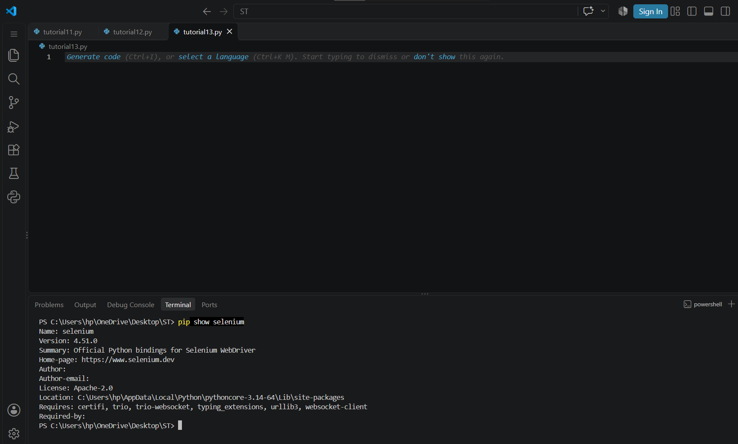

- Scenario ID: SET04
Scenario
Verify Selenium
Test Steps
1. Write selenium basic code
2. Check browser output
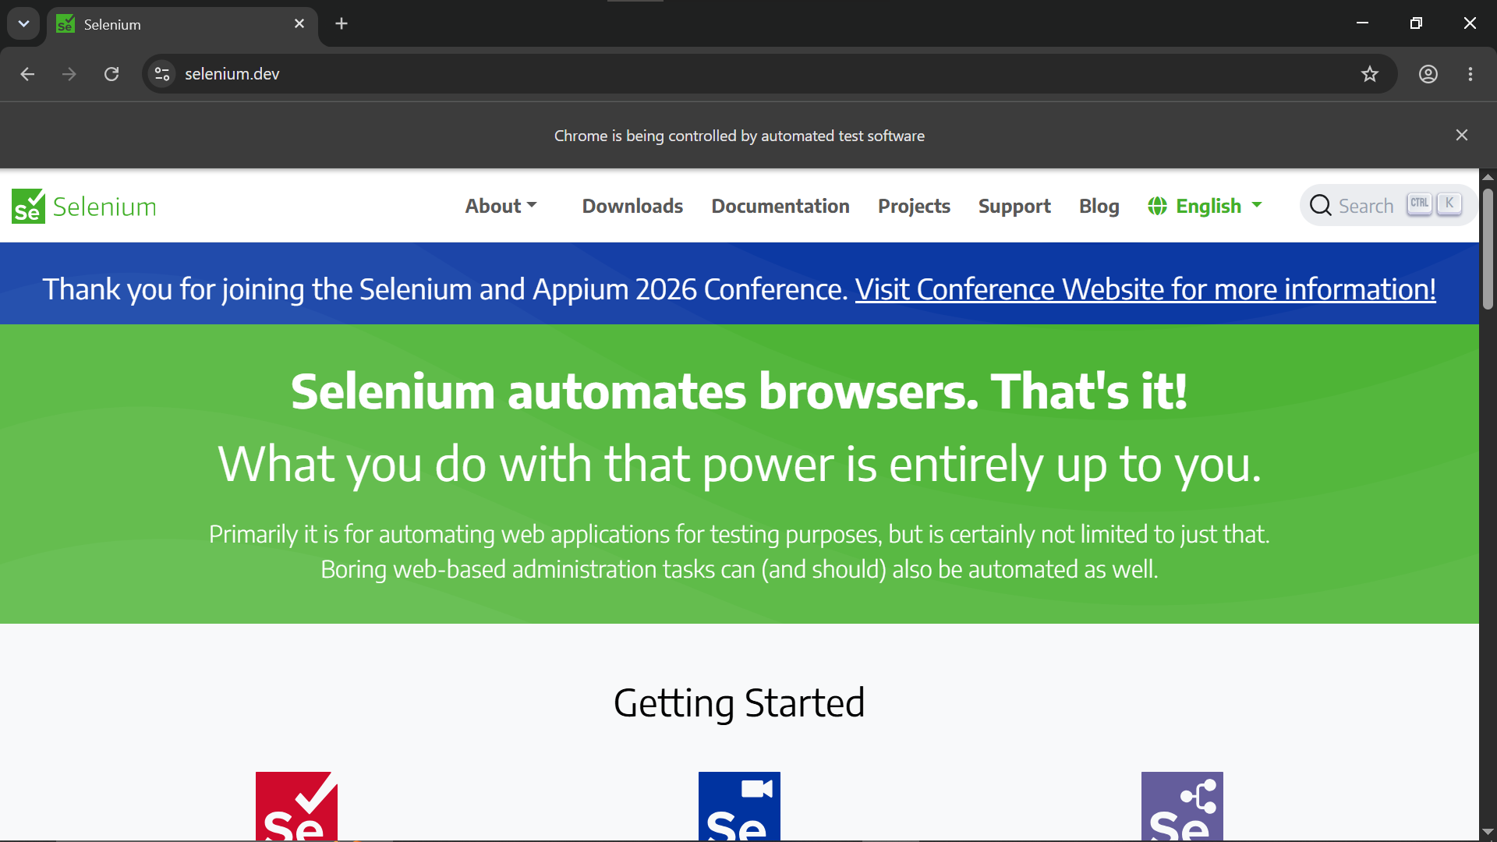

- Code:
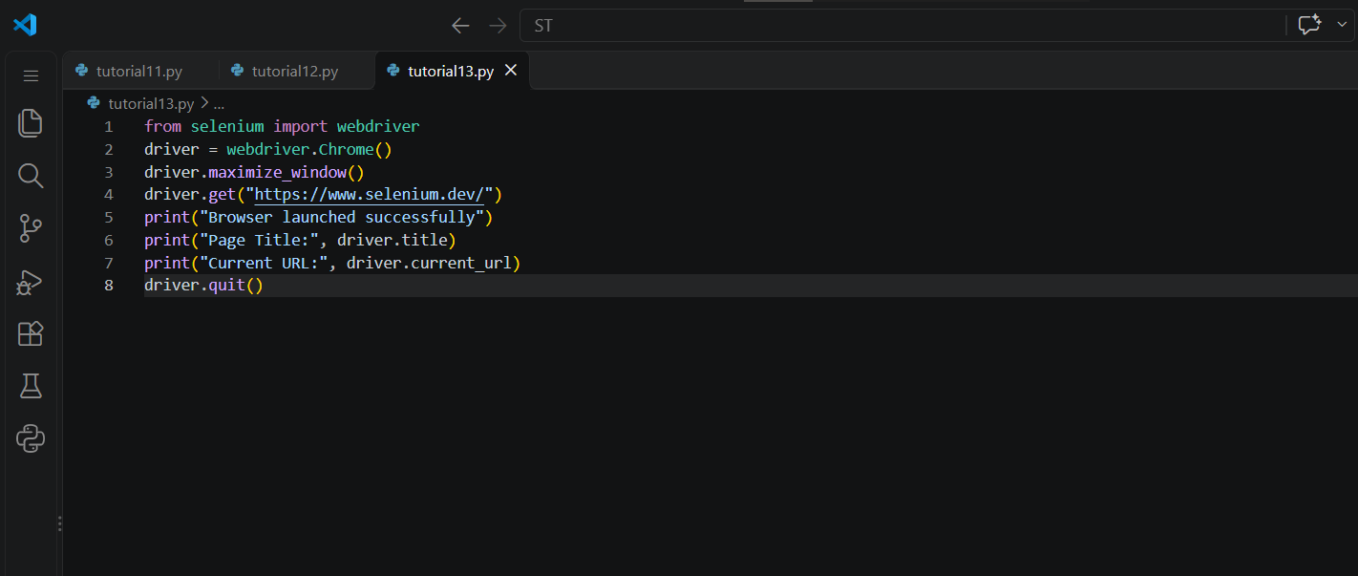

- Console Output:
